Final Project Milestone One

Organizational Background and Data Description

Michael Surdek
Southern New Hampshire University
DAT 640: Predictive Analytics
Professor Tom Woolman
January 16, 2022
Organizational Background
The Insurance Company (TIC) hopes to apply computational intelligence and statistical learning techniques in order to better understand its customers and thereby improve its marketing efforts. TIC provides many types of insurance including automobile, life, property, and social security. The organization has a large customer base, and in the past has seen less than stellar results from trying to promote all of its products and services to each and every customer, regardless of whether they already hold that type of policy or would even be interested in one at all.
It is clear that The Insurance Company could implement a better strategy of targeting its marketing campaigns to specific customers. The questions that remain are how can they determine which customers are likely to already hold a certain policy and what characteristics make a customer more likely to be interested in one. With this information, TIC would be able to avoid spamming its active customers and to limit the resources wasted on prospects who probably have no interest in a specific type of insurance. In this initiative, TIC will address these problems with a focus on caravan, or mobile home, insurance.
There are two particular tasks that can answer these questions based on evidence from a large dataset of insurance customers. First, they will need to develop a model that predicts the likelihood, from 0 to 100%, that a specific customer has a caravan insurance policy. “The underlying problem is to find the subset of customers with a probability of having a caravan insurance policy above some boundary probability. The known policyholders can then be removed and the rest receives a mailing.” (van der Putten, 2000) Second, they will identify the characteristics from the dataset that are associated with holding caravan insurance. The purpose of this task “is to give a clear insight to why customers have a caravan insurance policy and how these customers are different from other customers.” (van der Putten, 2000) One of the benefits of applying computational intelligence to these tasks is that multiple models can be generated automatically and they can be compared to each other. The model that is best for each task will be the one with the highest quality, meaning “hit rate, which should be maximized, and complexity, which should be minimized.” (Kim, 2000)

Data Set
The data that The Insurance Company can utilize was supplied by Sentient Machine Research (SMR) group based out of Amsterdam, the Netherlands. The data is stored across three files. The first file contains training data, which consists of 5822 records of 86 attributes, including the target variable “CARAVAN:Number of mobile home policies.” The second file contains validation data, another 4000 records of 85 attributes. The targets of the validation data are held out in the third data file.
There are two types of attributes in the datasets. Half of the attributes contain economic or demographic information, such as religion, marriage status, and income. The other half of the attributes contain product ownership information, which includes the number of policies as well as the monetary contributions towards each type of insurance policy: automobile, life, boat, etc. (van der Putten, 2000)
Each attribute in the data set is recorded as an integer value. Most attributes range from 0 or 1 to another single digit integer such as 5, 8, or 9. The first two attributes are the exceptions, ranging up to 41 and 10, respectively.
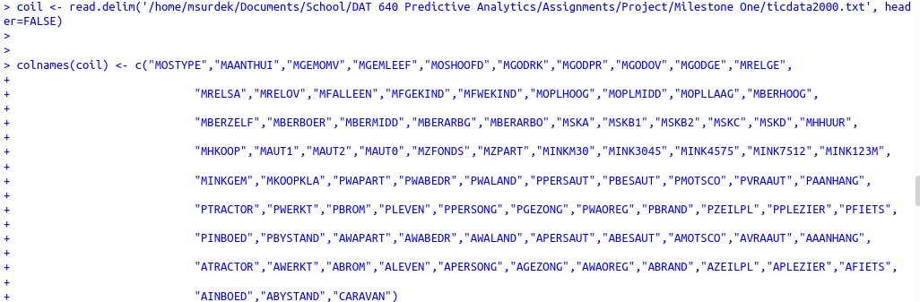
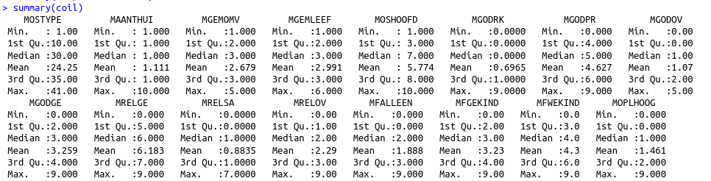
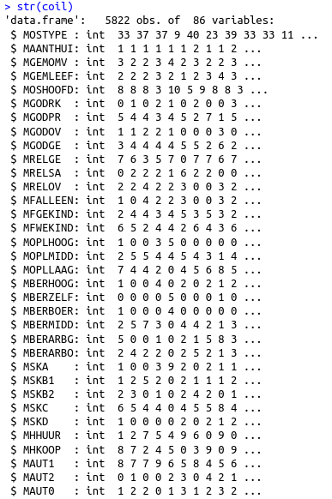
References:

Kim, YongSeog and Street, Nick. CoIL Challenge 2000: Choosing and Explaining Likely Caravan
Insurance Customers. University of Iowa Management Sciences Department. May 26, 2000. Retrieved from https://liacs.leidenuniv.nl/~puttenpwhvander/library/cc2000/STREET~1.pdf

van der Putten, Peter. de Ruiter, Michel. van Someren, Maarten. CoIL Challenge 2000 Tasks and Results: Predicting and Explaining Caravan Policy Ownership. Published by Sentient Machine Research, Amsterdam. Also a Leiden Institute of Advanced Computer Science Technical Report. June 22, 2000. Retrieved from https://liacs.leidenuniv.nl/~puttenpwhvander/library/cc2000/PUTTEN~1.pdf

